**Lab 8: Low Pass Filters**

Daniel Komac

EEE 117L

2:00pm-4:50pm

**Introduction:**

The purpose of this lab was to understand the sinusoidal response from first order filters and monitoring it with the oscilloscope and the effect of having a load resistor on the circuit. While in part two we analyzed Fourier series.

**Purpose:**

Low pass filters are circuit elements that allow us to pass filters of a certain frequency while attenuating frequencies that are higher than what the declared cutoff frequency is. We achieve proper analysis of Low pass filters through two types. One of which is a passive filter, composed of a resistor and capacitor in series (this will result in an output voltage less than the input. And an active circuit which uses an operational amplifier to invert and amplify the gain allowed for more precision over the desired outcome.

Oscilloscope with some noise issues, 180 phase shift (active filter):

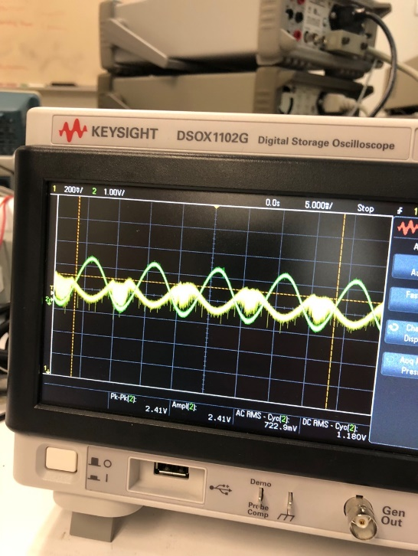

Passive Filters:

.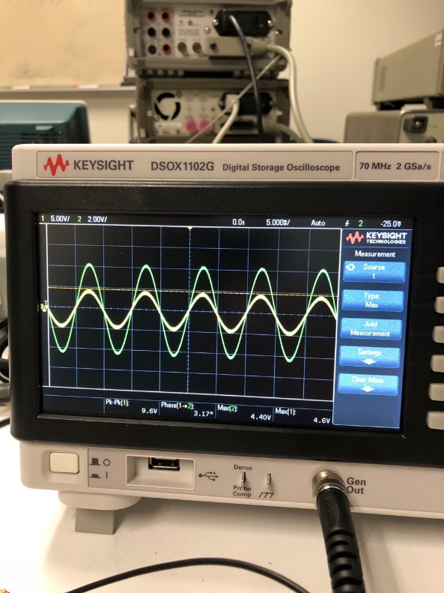

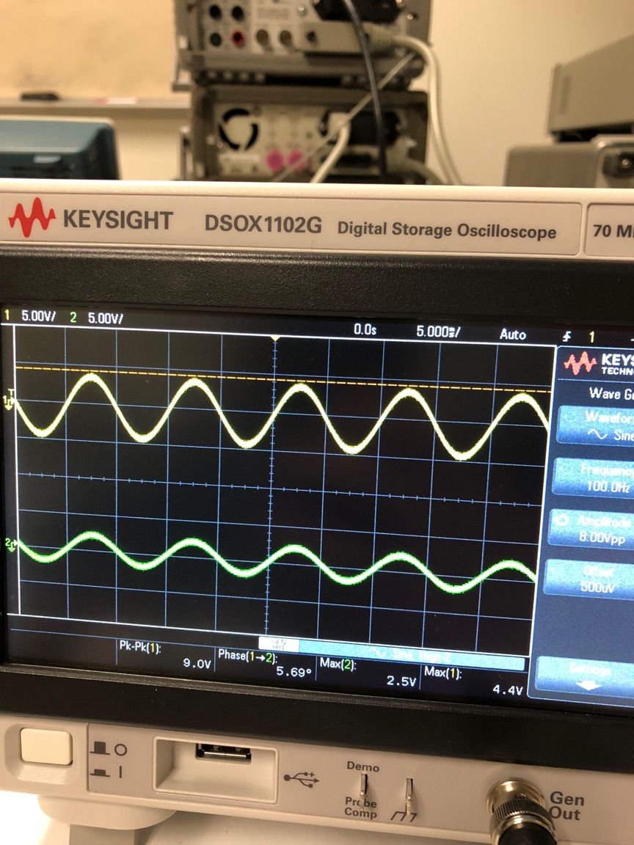

Part 2:

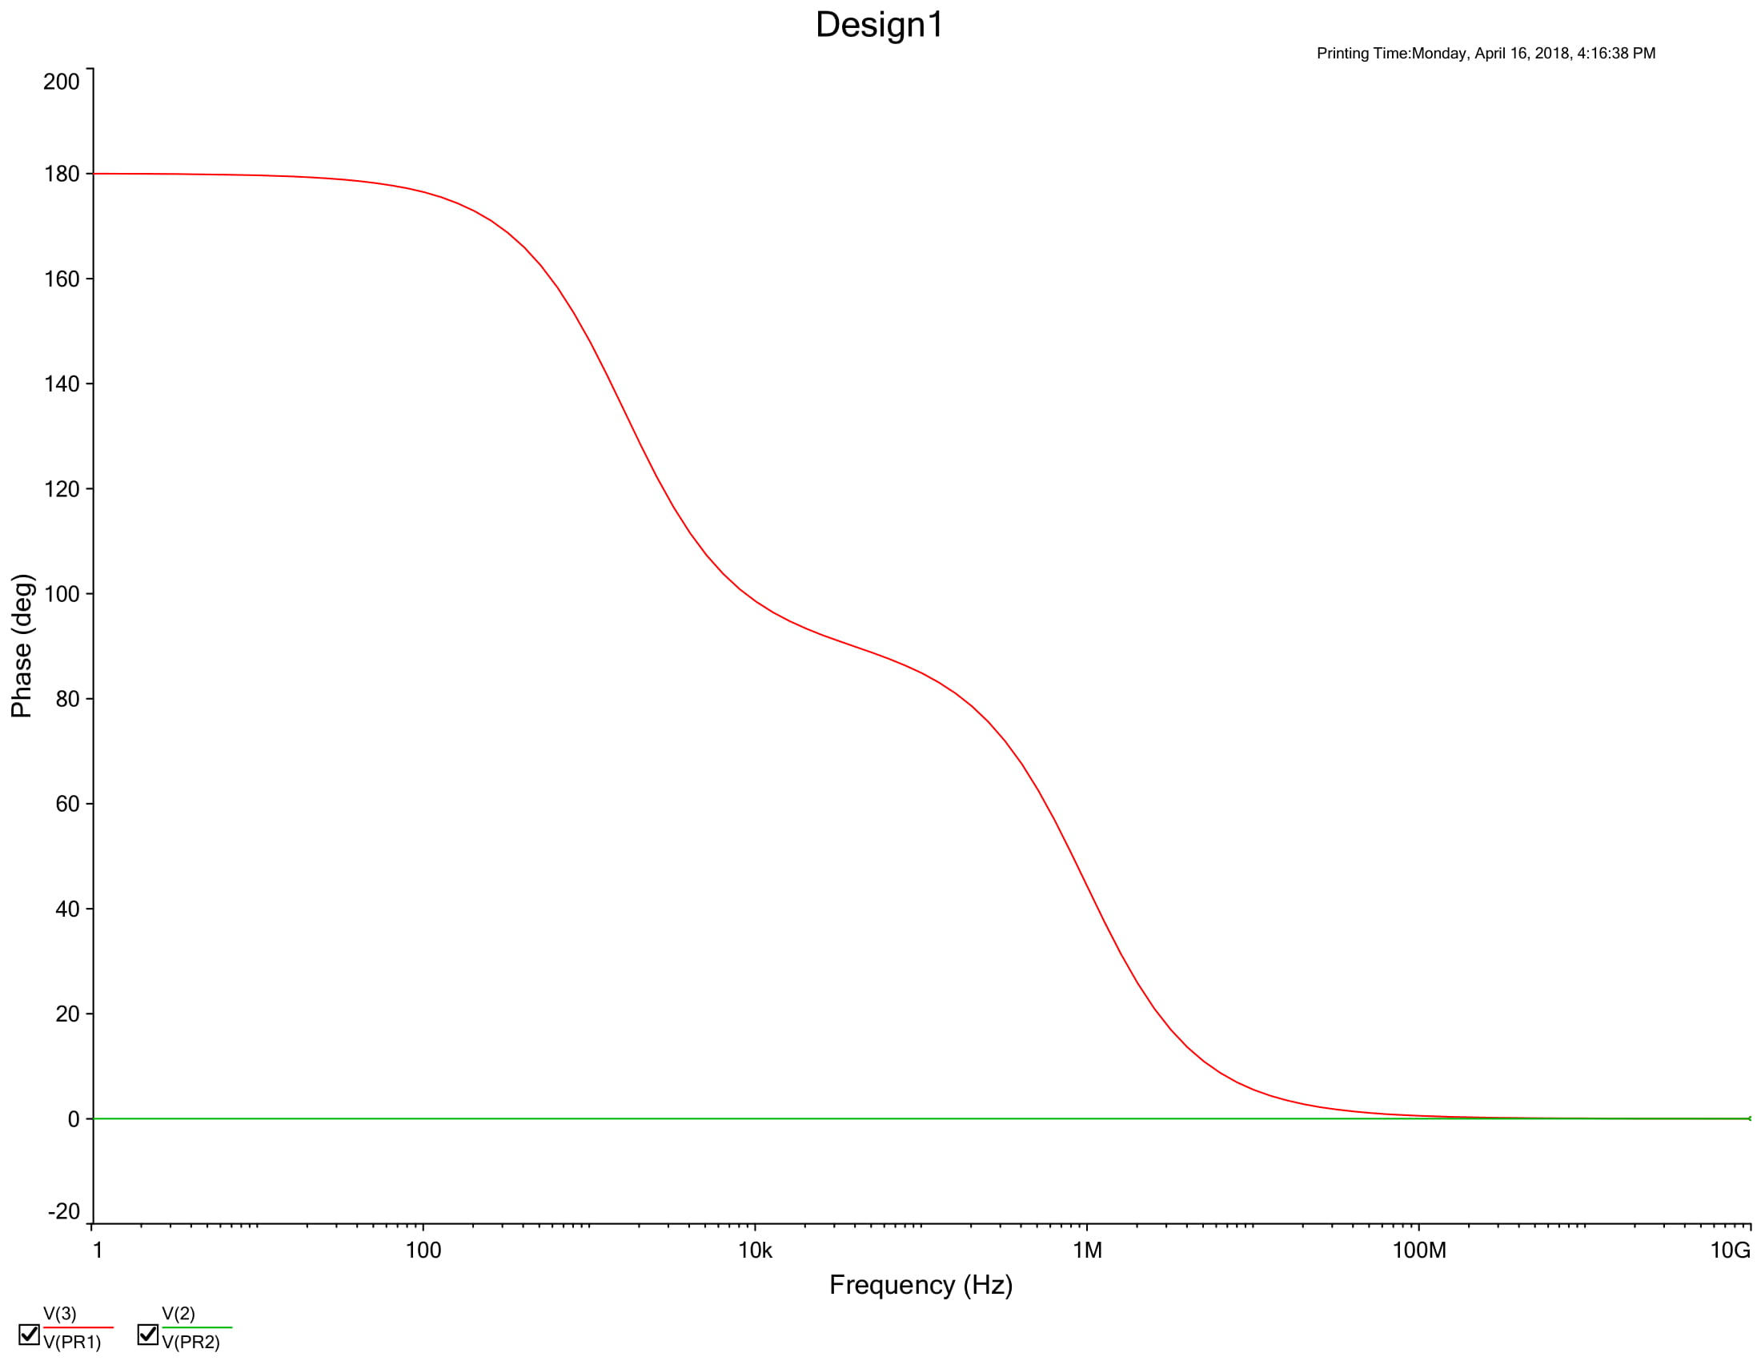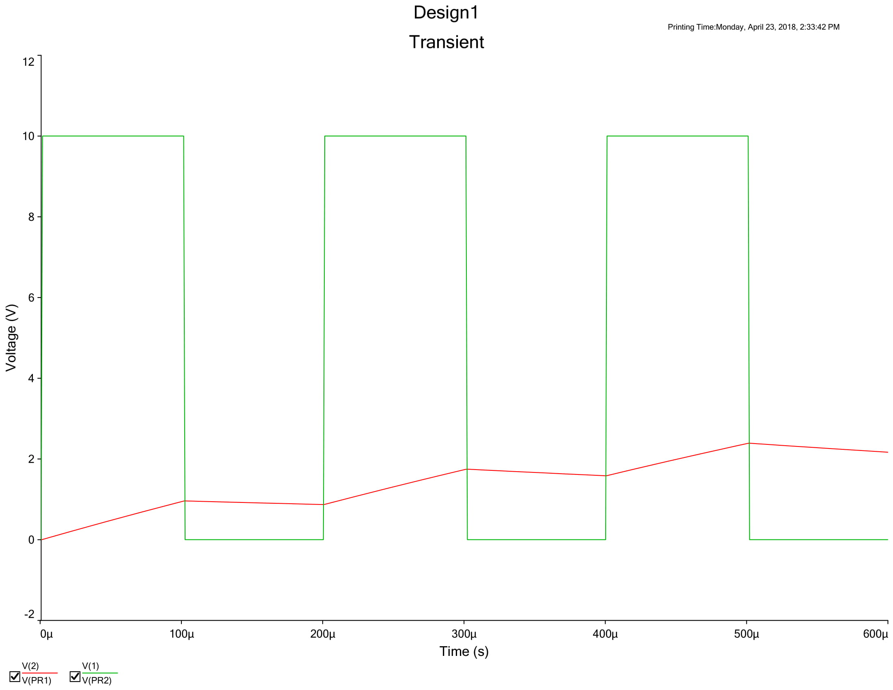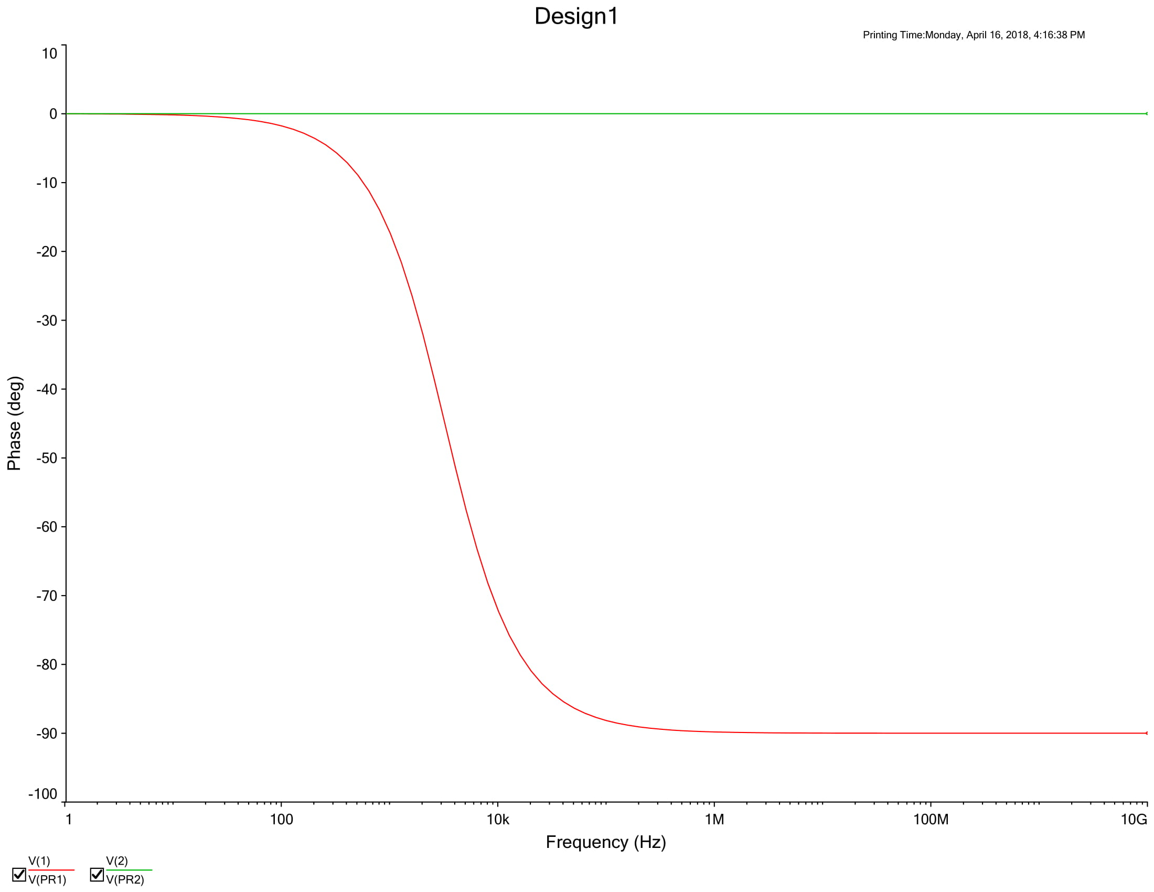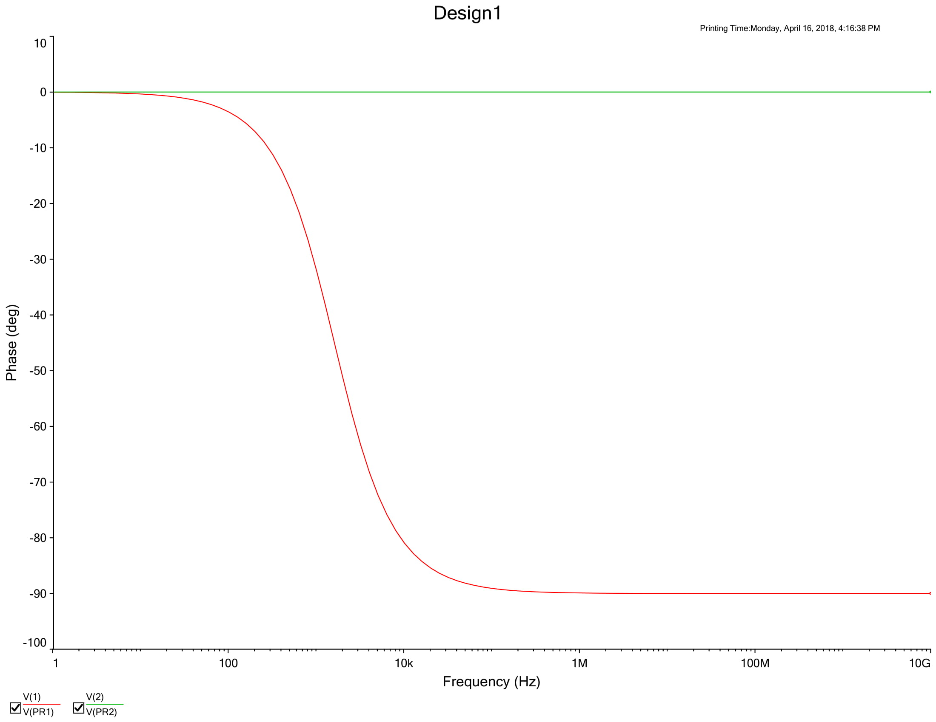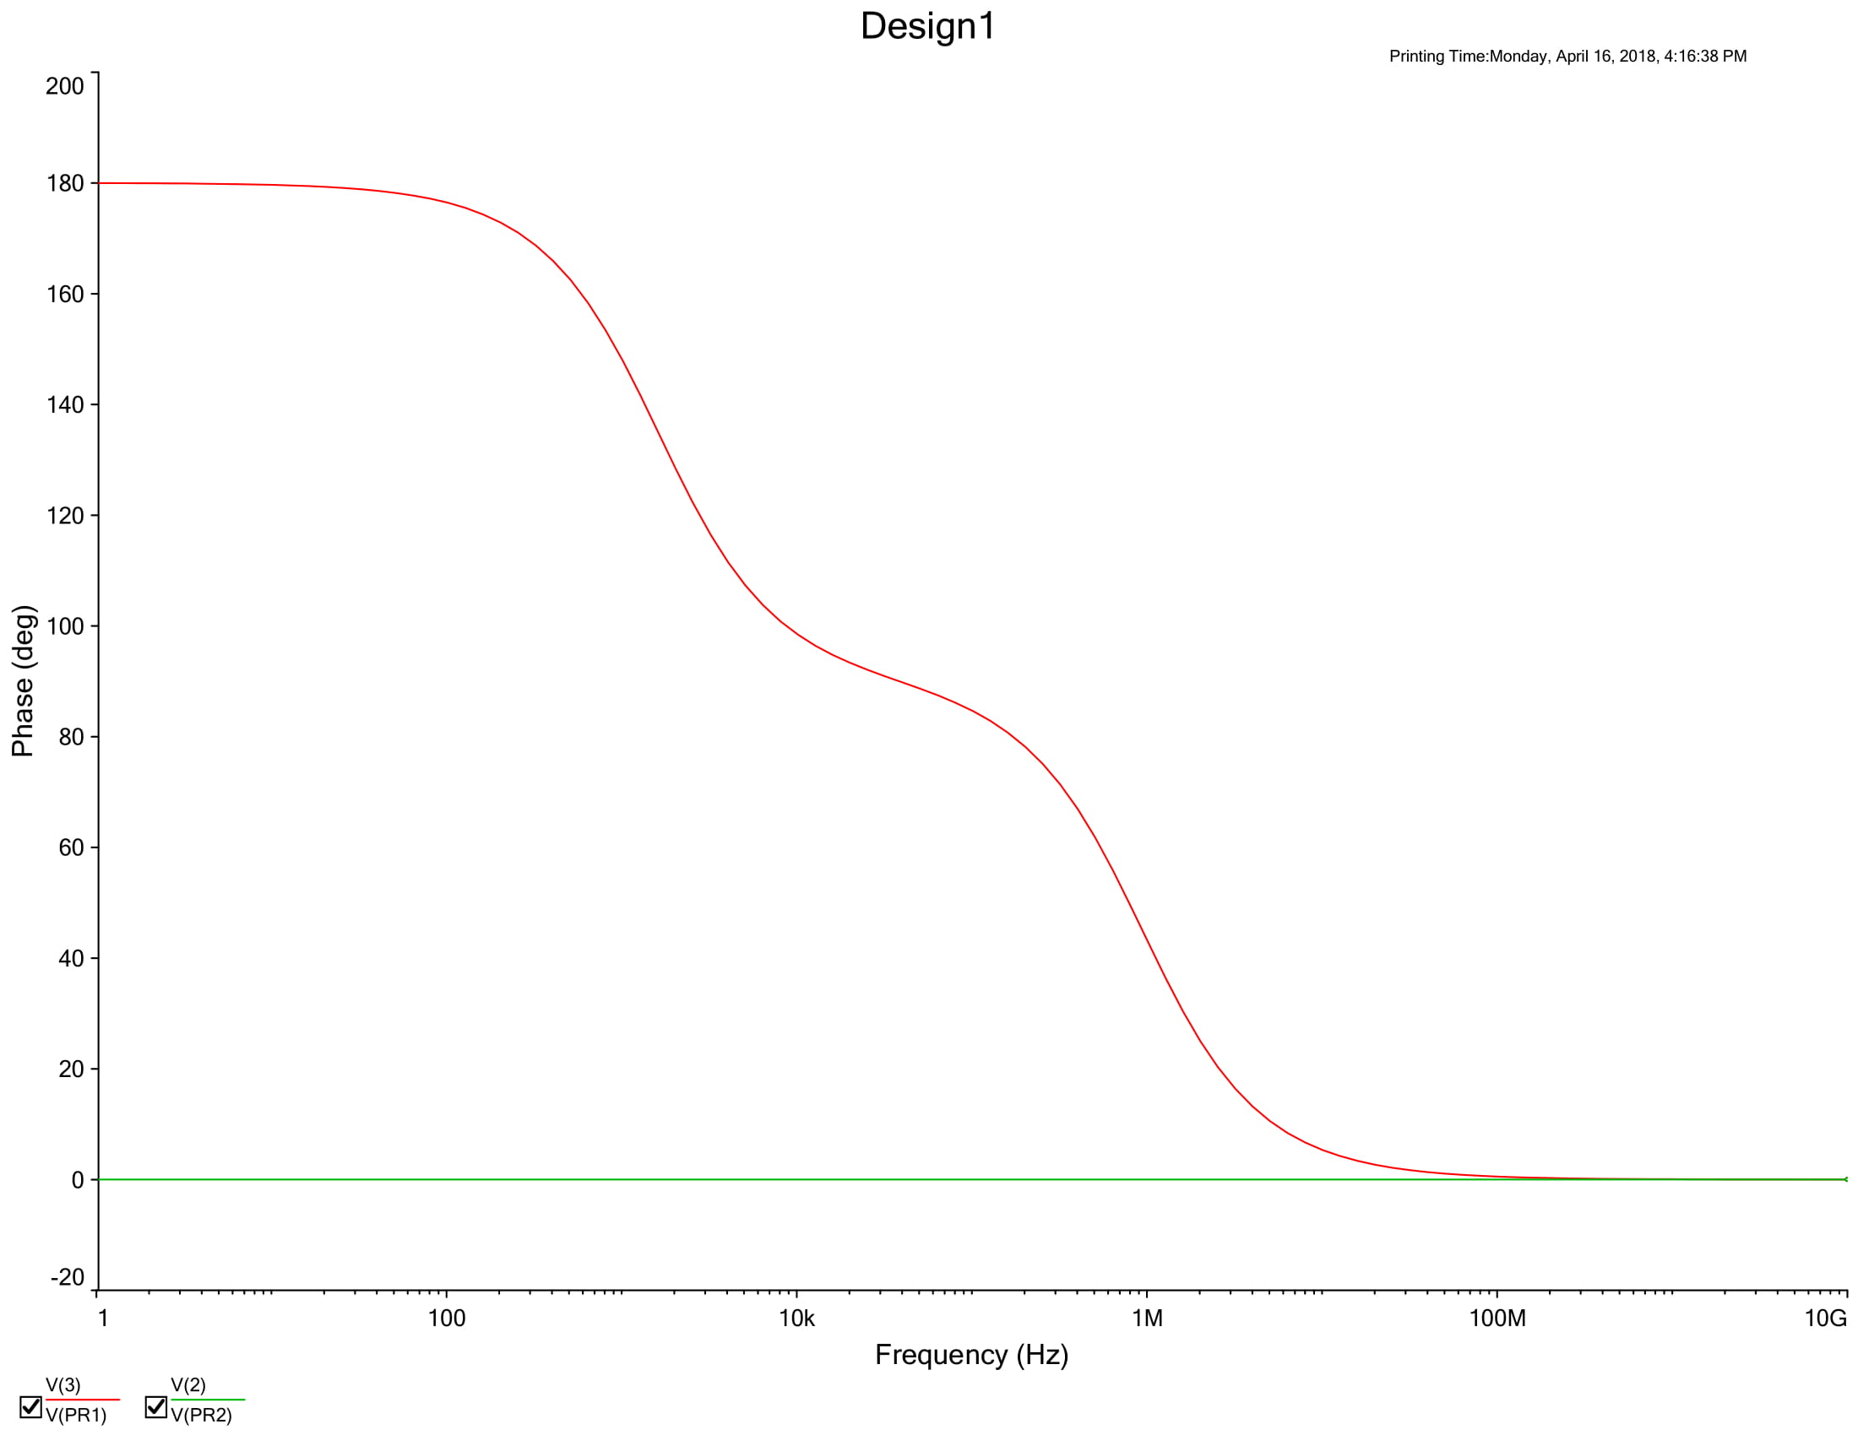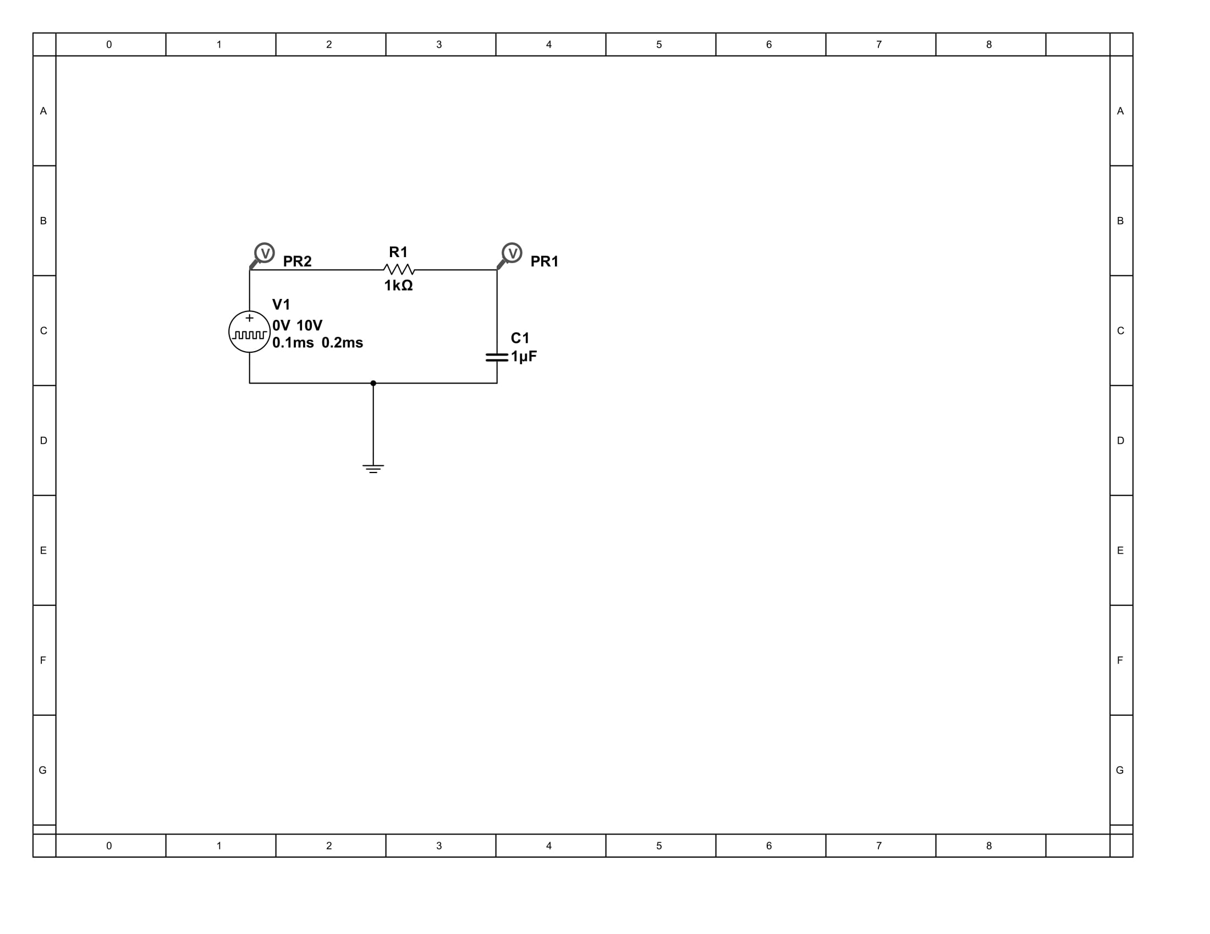

**Conclusion:**

This was an introduction to low pass filters and how they function. We studied the waveforms of both passive and active low pass filters while also analyzing theoretical and actual value of the output levels of the filters. Passive filters and active filters are similar except that active filters can control the precision of the desired gain and amplification. We also analyzed the effects of loaded and unloaded circuits in which the load would allow for a higher draw of frequency from the circuit to our output.